Design of a Hyperspectral Scanning Microscopic System
- Design procedure
The design of Hyperspectral Imaging System (HYSIS) is mainly comprised of three parts: Illumination system, Spectroscopic system and Detection system. The proposed optical system is designed using Ansys ZEMAX Optic-studio by utilizing the concept and specifications of optical components.

  - Illumination system
The Illumination system is divided into three components: a light source, a dual axis beam scanning system and microscopic imaging system. To ensure consistent optical performance, several system parameters are kept constant throughout the optical designing and optimization in ZEMAX. The aperture type is defined as numerical aperture of 0.25, the optical system is designed to operate on the visible range of 400 - 700 nm. For design simplicity, the Halogen light source (SLS301) is considered to be a point source which is passed through collimating lens ACL5040U-A of focal length 26 mm and produced a nearly 4 mm beam diameter, the beam diameter is calculated from ZEMAX simulation. The parallel beam of 4 mm diameter is passed through a dual axis mirror scanning system and a scanning lens (LSM-03-VIS). The dual axis mirror scanning system is designed using coordinate break and coordinate tilt/decenter functionalities. For system simplicity, we initially tilt the mirror in 45°, to make independent rotation of mirror along X and Y axis, the multi-configuration function and PRAM(Parameter) operand is utilized, which allows to vary, control or optimize a surface parameter across different configuration in the Multi Configuration Editor. In the designed, we used 5 configurations for rotating the mirrors in independent manner, the configurations are (0,0); (0,1.5); (0, -1.5); (1.5,0); (-1.5,0) which is shown in fig 1(b). To get the nearly constant spot size across the entire plane, a scanning lens (LSM03-VIS, Thorlabs) of focal length 39 mm having 10.6° scanning range is been incorporated. The scanning lens is placed at a distance of 10 mm from the mirror tilted about Y axis. The light beam from scanning lens is then directed to the sample through microscopic imaging system consisting of an achromatic doublet lens (AC254-100-A, Thorlabs) of focal length 100 mm as a tube lens and microscope objective lens (LMUL-10x-UVB, Thorlabs) of focal length 10 mm having 0.25 numerical aperture (NA).
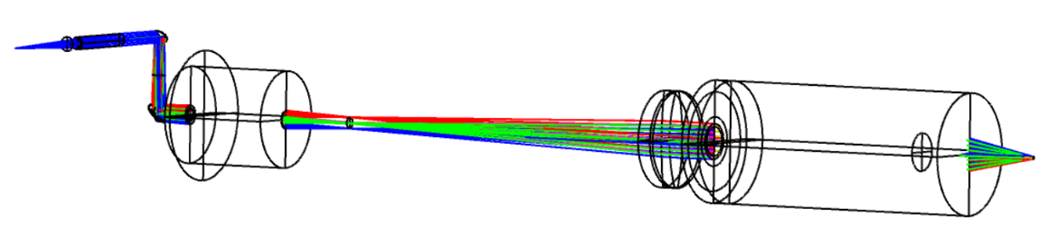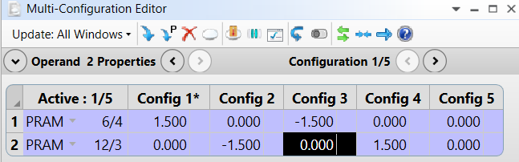
6
5
3
4
1
222
Fig 1(a) 3D layout of illumination system Fig:1(b) Snapshot of multiconfiguration editor

1.2 Spectral Imaging system
The Spectroscopic module is designed using Ansys ZEMAX Optic-studio by utilizing the concept of a Czerny–Turner spectrometer (CCT10, Thorlabs) consists of two spherical mirrors and a plane grating is shown in fig 1(c). In the simulation, a Czerny–Turner spectrometer of slit width 20 µm, grating groove density 600 lines/mm, spectral range 400–700 nm and spectral resolution of nearly 0.5 nm is designed which is shown in fig 1(d). For a spectrometer, the resolution can be expressed as
$Δλ=\frac{a}{mgf}$ ,
where a is the width of the slit, g is the grating groove density, and f is the focal length of the collimating mirror [1].
To simulate the system in ZEMAX Optic-Studio, we defined a narrow rectangular aperture of 1mm x 20 um which is acting as a slit in the designed environment. A hemispherical lens of radius 4.25 mm of thickness 2mm is selected and is placed 2.84 mm distance from the entrance slit. To collimate the divergent light from the slit, a collimating mirror of radius 150 mm is placed at a distance of 65.26 mm from the hemispherical lens with a tilt angle -5° about x axis. The collimated light beam is then allowed to hit the grating with an incident angle 5° of groove density 600 lines/mm placed at distance of 100 mm from the collimating mirror with tilt angle 20° along y axis. The incident angle is calculated using basic geometry and the diffraction angle of the light beam can be calculated using grating diffraction equation
$mgλ=\left(\sin{α}+\sin{β}\right)$ ……………………………………………... (1)
where $α$= 5° incident angle which can be calculated from basic geometry and $β$ is reflected angle which can be find out using equation (1), $λ$ is the primary wavelength 587 nm and m is the order of grating, taking m= +1.
A focusing mirror of radius 190 mm is placed at a distance of 100 mm from the grating with tilt angle -7° about x axis to focus the light on the detector plane.
collimating mirror
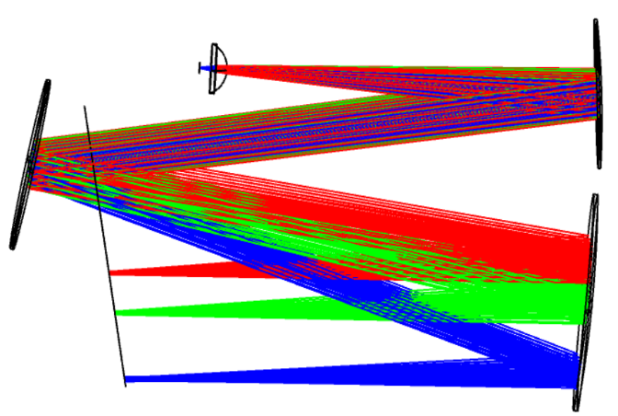

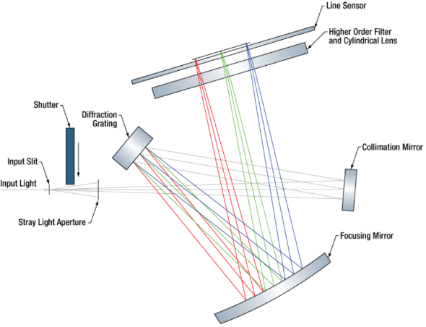
slit
focusing mirror

grating
Fig 1(c): Schematic of Czerny–Turner spectrometer Fig 1(d): Designed 3D layout of spectrometer module
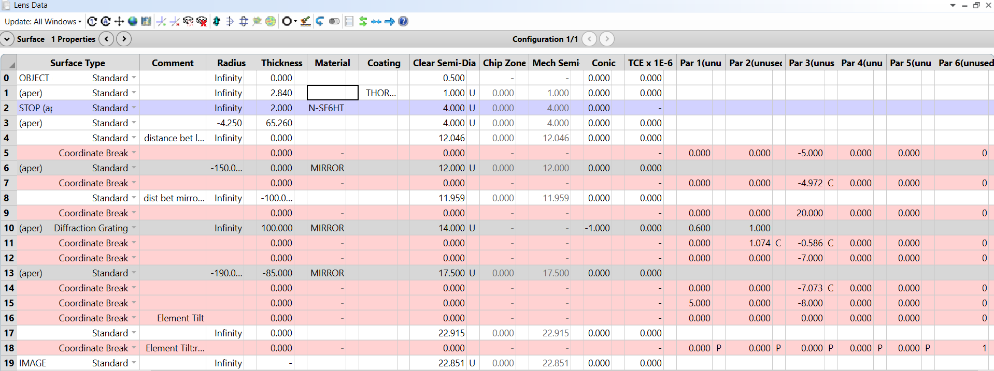
Fig 1(e): Lens Data Editor of designed spectrometric system
  - Detection system
The detection system is designed for collecting the optical signal reflected from the sample and delivering it to the spectrometer for spectral analysis. In the designed imaging system, a back-reflection configuration is utilized, where the light reflected from the sample retraces the illumination path through the imaging optics. To maintain the design simplicity, a mirror is inserted after the dual axis scanning mirrors to reflect the back tracing light and deliver to the spectrometer module. The redirected light is focused by a fiber coupling lens (AC080-010-A) of focal length 10 mm into an optical fiber, the coupling lens is chosen in such a way that the numerical aperture of the of the coupling lens must not exceed the numerical aperture of the optical fiber (0.22 NA).

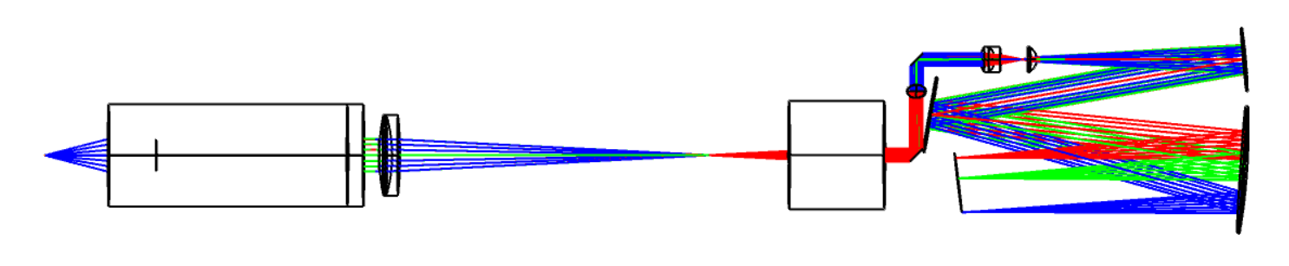
5
4
8
6
3
7
Fig 1(c) 3D layout of designed detection module
- Result
The designed HYSIS combines spatial imaging with spectral analysis, thus the performance of system is evaluated by the primary parameters: field of view (FOV), magnification and spatial resolution of microscopic imaging module while the spectral resolution is the key performance parameter of the spectroscopic module. The field of view of the designed system is determined using the footprint diagram generated in ZEMAX Optic Studio. The footprint diagram provides the distribution of optical rays across the image plane and enables the determination of the maximum scanning region. The FOV of scanning lens is 6.2 mm which is shown in fig 2(a) and microscope objective (MO) lens is 1.26 mm which is shown in fig:2(b). The designed system contains scan lens, tube lens and microscope objective lens, the scan lens and tube lens form a relay system, while the tube lens and microscope objective lens form an infinity corrected system, so the overall magnification of the system is the magnification due to relay system and magnification due to infinity corrected system. For an infinity corrected system, magnification (M_{I}) is the ratio between the focal length of tube lens (f_{t} = 100 mm) to the focal lens of microscope objective lens (f_{m}= 10 mm), that is $M_{I}=\frac{f_{t}}{f_{m}}$ = 10x, while for the relay system, the magnification (M_{R}) is the ratio between focal length of tube lens (f_{t} = 100 mm) and focal lens of scanning lens (f_{s} = 39 mm), that is $M_{r}=\frac{f_{t}}{f_{s}}$ = 2.56x. And the overall magnification of the system is given by,
M _{system} = M_{I} ×M_{R} = 25.6x
The spatial resolution due to microscope objective provides the ability of the system to observes and distinguish the two closely spaced point objects distinctly which is another important parameter to determine the system performance and is given by,
$δ=\frac{0⋅61λ}{NA}$,
For primary wavelength $λ=0.587 µm$, the spatial resolution is about 1.44 $µm$.
For determining the performance of spectroscopic module, the spectral resolution is calculated which is defined as the ratio between the image width in the image plane (W) and the linear spectral dispersion (D), that is
$Δλ=\frac{w}{D}$
the experimentally calculated spectral resolution is 0.99 nm for primary wavelength (0.587 nm), while for primary wavelength (0.587) the theoretically calculated spectral resolution is 0.5 nm. The image width is determined from the RMS spot size generated in ZEMAX and linear spectral dispersion is determined using REAY operand in Multi Configuration Editor which is shown in fig 6(a),(b),(c). The spot diagram of each wavelength for all different fields is also shown in fig:3
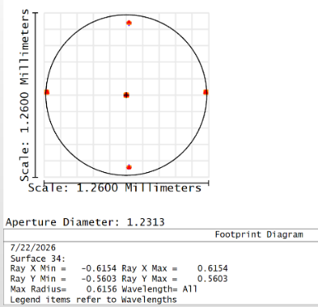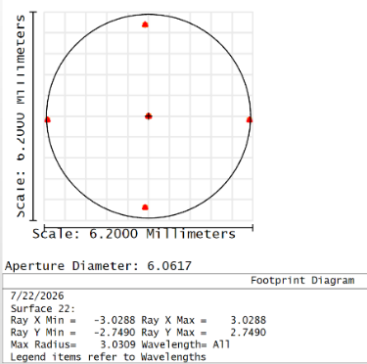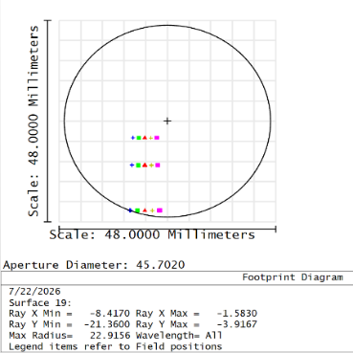

Fig: 2(a) FOV of MO Fig:2(b) FOV of scan lens Fig:2(c) Footprint diagram of entire system
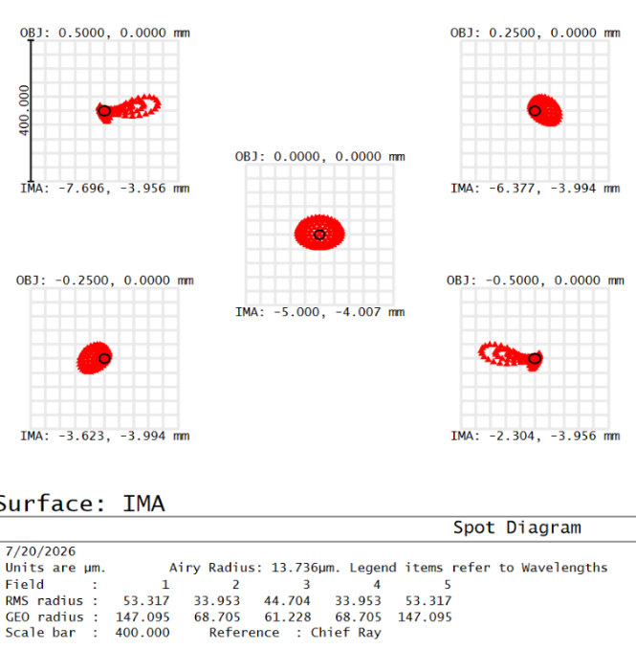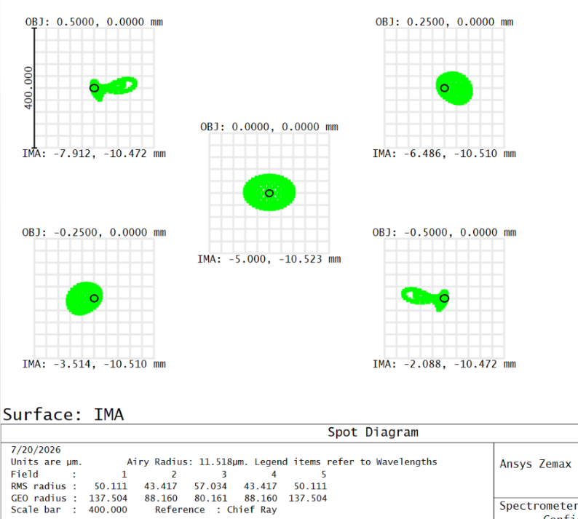

3(b)
3(a)
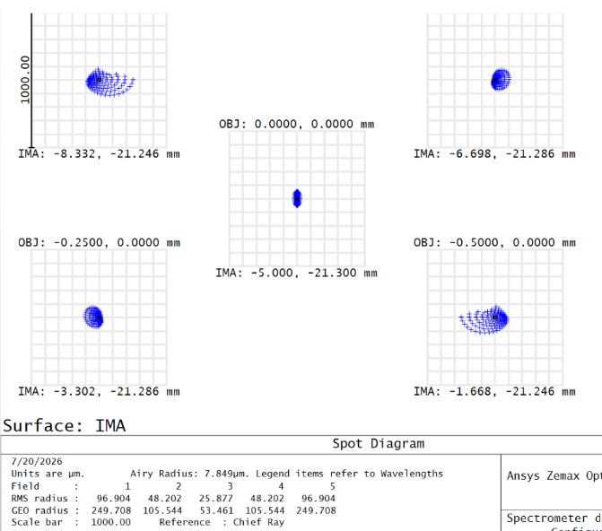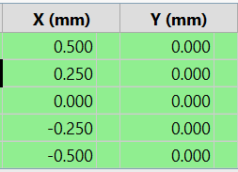
3(d)
3(c)
Fig 3 (a), (b), (c) spot diagram of light beams at the detector for different wavelengths, (d) snapshot of different field values along x-axis.
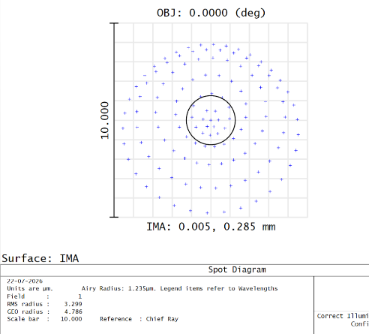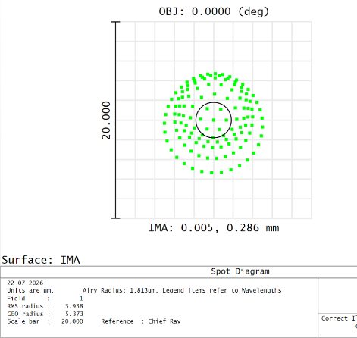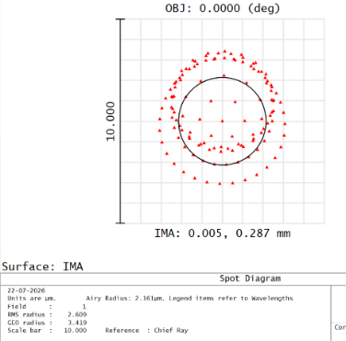
4(c)
4(b)
4(a)
Fig 4: Spot diagram of light beams after MO (a) for 400 nm, (b) for 587 nm, (c) for 700 nm
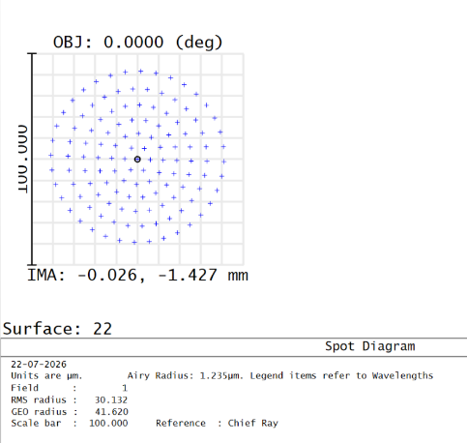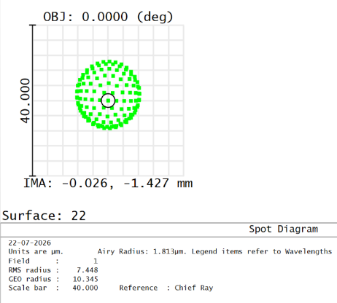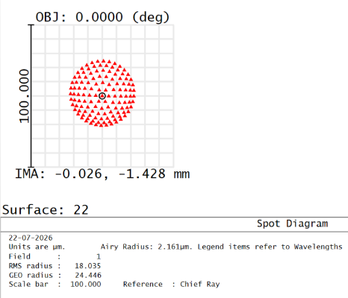
5(a)
5(b)
5(c)
Fig 5: Spot diagram of light beams after scan lens (a) for 400 nm, (b) for 587 nm, (c) for 700 nm
6(b)
6(a)
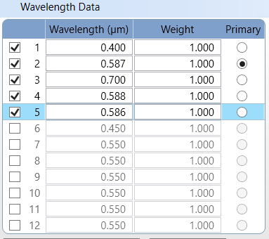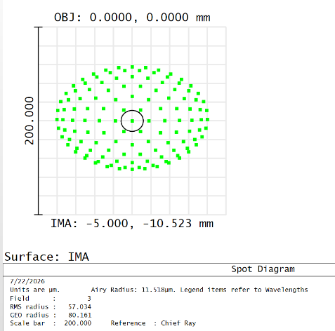
6(c)
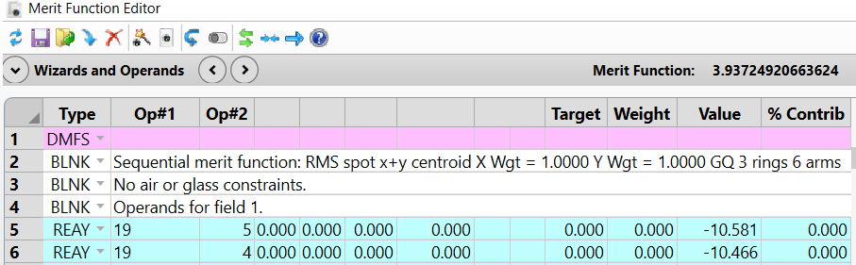
Fig: Snapshots of 6(a) wavelength data for two nearest wavelength 6(b) spot size or image width on image plane for 587 nm wavelength, 6(c) Merit Function Editor for calculating the linear dispersion between two nearest wavelength

- Components used
 | Serial no. | Optical elements | Thorlabs part number | Source
Illumination Module | 1 | Halogen light source | SLS301 | https://www.thorlabs.com/item/SLS301
 | 2 | Liquid light guided adapter with collimating lens | SLSLLG3 | https://www.thorlabs.com/item/SLSLLG3
 | 3 | 2D Galvo scanning system | GVS202 | https://www.thorlabs.com/item/GVS202
 | 4 | F-theta scanning lens | LSM03-VIS | https://www.thorlabs.com/item/LSM03-VIS
 | 5 | Achromatic doublet lens | AC254-100-A | https://www.thorlabs.com/item/AC254-100-A
 | 6 | Microscope objective | LMUL-10X-UVB | https://www.thorlabs.com/item/LMUL-10X-UVB
Spectrometer Module | 7 | Fiber coupling lens | AC080-010-A | https://www.thorlabs.com/item/AC080-010-A
 | 8 | Compact Spectrometer | CCT-10 | https://www.thorlabs.com/item/cct10

Table 1: List of components used in designing the optical system

- Summary
The proposed hyperspectral imaging system is designed and optimized using ZEMAX Optic Studio to achieve high spatial and spectral performance. A dual axis scanning microscopic system is designed along with a design of Czerny–Turner spectrometer. The scanning optical system provided a theoretical field of view (FOV) of 7.21 mm and the FOV after microscope objective 2.4 mm, while the simulated FOV of the scan lens is 6.2 mm and the FOV after microscope objective is 1.26 mm. The total magnification of designed optical system is 25.6x. The spectrometer is designed using a 600 lines/mm diffraction grating and a 100 mm focal length focusing mirror. Based on theoretical calculations, the spectral resolution of spectrometer 0.5 nm. However, the resolution obtained from the ZEMAX simulation is 0.99 nm. The combination of a microscopic imaging system providing millimeter-scale spatial scanning and a spectrometer module exhibiting nanometer scale spectral differentiation satisfying the fundamental requirements of a hyperspectral imaging system.

- Reference
- Wu, S., Wang, T., Huang, C., Gu, J., Yu, L., Xue, H., & Shen, Y. (2022). Advanced optical design of Czerny–Turner spectrometer with high flux and low aberration in broadband. Applied optics, 61(11), 3077-3083.

-------------------------------------------------------------

